Table of Content

- Introduction
- Purpose
- Scope
- What is Cloud Computing?
- Types of Clouds
- Cloud Computing Architecture
- Software as a Service(SaaS)
- Infrastructure as a Service(IaaS)
- Platform as a Service(PaaS)
- Security
- Need of Security in Cloud Computing
- Current Security Scenario
- Suggested Solutions
  - Encryption
  - Compression
  - Stenography
  - Tokenization
- System Design
- Technologies used
Introduction
Cloud computing is Internet based system development in which large scalable computing resources are provided “as a service” over the Internet to users. The concept of cloud computing incorporates web infrastructure, software as a service (SaaS), Web 2.0 and other emerging technologies, and has attracted more and more attention from industry and research community. In this paper, we describe our experience and lessons learnt in checking the reliability and security of the cloud. Security is one of the most important issues associated with the real world use to the cloud. Also, Cloud reliability analysis and modelling are not easy tasks because of the complexity and large scale of the system. We aim to attain, through this report, a better understanding to the subject and to make it more reliable and secure to store confidential data.

Purpose
Cloud computing is a recently developed new technology for complex systems with massive scale service sharing, which is different from the resource sharing of the grid computing systems. Cloud reliability analysis and modeling are not easy tasks because of the complexity and large scale of the system. This paper systematically analyzes cloud computing and models the reliability of the cloud services. Various types of failures are interleaved in the cloud computing environment, such as overflow failure, timeout failure, resource missing failure, network failure, hardware failure, software failure, and database failure In the current scenario sectors like banking and others are still using the traditional way (servers) and are not using cloud due the reliability of cloud due to security and performance. The purpose of our project is to find a way to make cloud more reliable to use for the sectors other than IT.

Scope
A paradigm shift to cloud computing will affect many different sub-categories in computer industry such as software companies, internet service providers (ISPs) and hardware manufacturers. While it is relatively easy to see how the main software and internet companies will be affected by such a shift, it is more difficult to predict how companies in the internet and hardware sectors will be affected.
The implementation of cloud will aim at reduced cost, centralization of data, scalability, monitoring of performance, improvements for systems that are often only 10–20% utilized. In short the affects of shifting completely to the cloud will affect the entire industry and more.

What is Cloud Computing?
Cloud Computing is a broad and ill-defined term, but in essence it amounts to virtualized third-party hosting. That is, rather than renting part or all of an actual physical server from a hosting company, you rent a certain amount of server resources. Your server runs inside a virtual container which can be moved from one physical server to another without interruption of service. Such a container is also capable of spanning multiple physical machines, giving it potentially limitless resources.
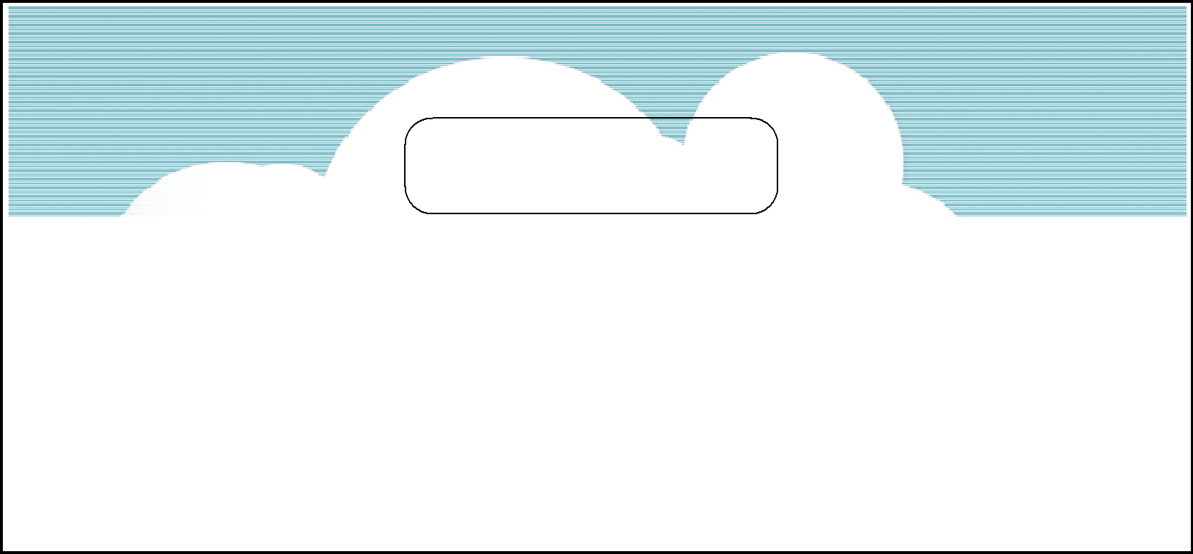
A web server typically has three tiers to it: The physical infrastructure, the operating system platform, and the web application software being run. A cloud container may contain one, two or all of these layers:

Software
Infrastructure

Platform


Choosing an appropriate cloud provider is often a matter of selecting which layers you wish to control yourself, and which should be the responsibility of the hosting provider.
In brief, the options are these:
- If you want a fully operational server with total control over the operating system and configuration, you want Infrastructure as a Service.
- If you don’t want any configuration hassles at all, if you just want to upload your files and leave your website to run, you want Software as a Service.
- For something in between, with a pre-configured operating system but a reasonable amount of control over the rest of the configuration, Platform as a Service is for you.
It is important to understand that the requirement that drove the development of Cloud Computing was scalability. With dedicated or shared servers, an increase in traffic can leave the site badly underpowered. This is a major obstacle to the development of new mass-market web applications, since upgrading to better hardware is a difficult and time-consuming process, but start-ups generally can’t afford powerful server farms from the start.

Types of Cloud
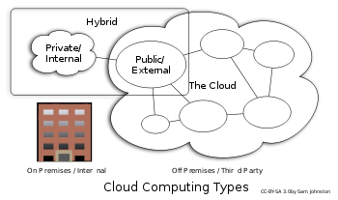
Public cloud:
Public cloud describes cloud computing in the traditional mainstream sense, whereby resources are dynamically provisioned to the general public on a fine-grained, self-service basis over the Internet, via web applications/web services, from an off-site third-party provider who bills on a fine-grained utility computing basis.
Community cloud:
Community cloud shares infrastructure between several organizations from a specific community with common concerns (security, compliance, jurisdiction, etc.), whether managed internally or by a third-party and hosted internally or externally. The costs are spread over fewer users than a public cloud (but more than a private cloud), so only some of the benefits of cloud computing are realized.

Hybrid cloud:
Hybrid cloud is a composition of two or more clouds (private, community, or public) that remain unique entities but are bound together, offering the benefits of multiple deployment models. It can also be defined as a multiple cloud systems that are connected in a way that allows programs and data to be moved easily from one deployment system to another.
Private cloud:
Private cloud is infrastructure operated solely for a single organization, whether managed internally or by a third-party and hosted internally or externally.
They have attracted criticism because users "still have to buy, build, and manage them" and thus do not benefit from lower up-front capital costs and less hands-on management, essentially "[lacking] the economic model that makes cloud computing such an intriguing concept".

Cloud Computing Architecture
Cloud computing architecture, just like any other system, is categorized into two main sections: Front End and Back End. Front End can be end user or client or any application (i.e. web browser etc.) which is using cloud services. Back End is the network of servers with any computer program and data storage system. It is usually assumed that cloud contains infinite storage capacity for any software available in market. Cloud has different applications that are hosted on their own dedicated server farms.

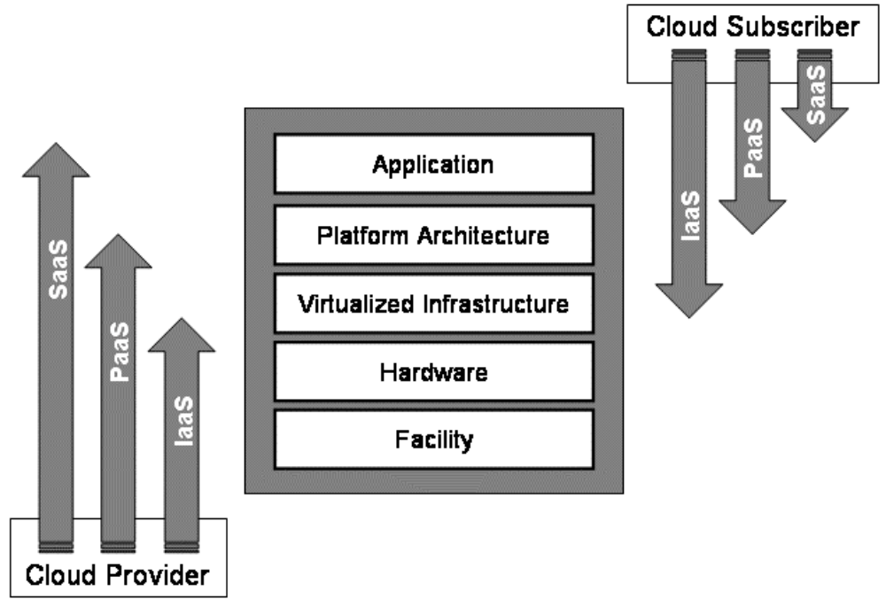

- Software as a Service (SaaS)
“Software as a Service” has of late become something of a marketing buzzword, and is inevitably misused, but there seem to be two types of offering that fall into this category.
The first is virtualization of internal systems – a large company’s CRM or ERP is moved from intranet servers into the cloud and hosted on shared servers. This applies both to custom-written systems and commercial applications like Microsoft SharePoint. There are a number of companies that specialize in single-application hosting of this type, and a useful directory to these is available here.
The second type is the simplest form of cloud computing: effectively virtualized shared-server space into which you put anything you want. This is an internal business application, but it could equally be a public-facing website.
This type, works almost exactly the same as regular shared server hosting. The host gives you access to a virtual directory to which you can upload a single website’s files, but any changes to the platform or environment have to be handled by the hosting company. For multiple web applications, you need multiple SaaS virtual sites, which are charged separately but can all be managed though a single web console.
So how is SaaS better than an ordinary shared server? With SaaS, the website exists in a virtual container, which can be moved from physical server to physical server without interruption of service. This makes it much easier to transfer the site to more powerful hardware as the need arises, but all of the other limitations of shared servers still apply: very limited configurability, no third-party software or background services, and so on.

1.1. Disadvantages
Most of the disadvantages of SaaS are the same as those that apply to ordinary shared hosting; the relative severity of the disadvantages will of course depend on your specific circumstances.
Much of the security burden falls on the hosting company. You would have to trust them to properly secure the server(s) on which the virtualized application runs, as well as the firewall controlling network security.
You would have no control over what other applications are sharing the same server; each other application provides a potential point of entry for hackers, and poorly written software might have adverse effects on the stability of the operating system. This is slightly mitigated by virtualization; in the event of server instability, the hosting company could easily transfer the site to a different server. You would however be reliant upon them to monitor their systems closely and expedite the move.
Audit trails and service monitoring are more difficult to achieve in a virtualized environment, since you would have no direct access to the system logs. If you need log access, you would have to configure your application to handle it internally.
1.2. Advantages
The biggest advantage of SaaS, as with all cloud computing, is its scalability. Virtualized applications can be moved onto different hardware extremely quickly in response to increased demand. SaaS also shares the other standard advantages: easy backups, flexible pricing, portability, and so on.
Compared to other forms of cloud computing, SaaS is extremely user-friendly, with the hosting company taking most of the maintenance burden.
SaaS solutions also have the potential to be extremely cheap if you have simple requirements and don’t expect a huge amount of traffic.

1.3. Example: Rackspace Mosso


Rackspace are one of the really big names in traditional hosting, so it makes sense to consider their new cloud-based offering: Mosso. Their basic package (priced in US dollars) starts at $1200 per year. For this price, you get:
- 500 GB of bandwidth per month.
- 50 GB of hard disk space.
- 10,000 compute cycles1 per month.
It’s a little peculiar that this is their basic offering; a typical site would need tens of thousands of monthly visitors to get anywhere near the 500GB limit, so one might have thought there would be a more limited (and therefore cheaper) option available.
All the same, $100 per month does look like good value if you are expecting high traffic volumes for your site, and the incremental cost of going beyond the standard package (50c per GB of storage, 25c per GB of bandwidth, 1c per compute cycle) is attractively low. You can also get a 100MB SQL Server database for $5 per month extra.
For basic starter sites, however, there are better options out there.

1.4. Example: WebFusion


If you’re looking to host a small site, WebFusion seems a decent option. Their basic package is priced at just £48 per year, for which you get 1.5GB of disk space and 20GB of traffic per month. However, at the moment this offering only supports ASP.NET 1.1.
For sites that require .NET 2.0/3.5 and a SQL server database, the cost would be a still-reasonable £180 per year. This includes 10GB of disk space and 150GB of traffic.

- Infrastructure as a Service(IaaS)
For all the convenience of hosted web applications, there is a lot to be said for the control that comes with having access to the entire server, from the operating system on up. In cloud computing, this is possible through Virtual Private Servers.
With a Virtual Private Server, all that is abstracted away is the hardware. Logging in to a VPS is practically indistinguishable from logging in to a remote server via Terminal Services. If you have a dedicated server in a hosting centre somewhere, moving to VPS should leave you with an almost identical experience.
Virtual Server technology is not new. Developers have been using it for years to set up test platforms for new applications, or to subdivide physical machines into multiple logical servers. Using a virtual machine to host a web application was uncommon, however, because the virtual server would by definition have to be less powerful than the physical server on which it was running. What makes IaaS interesting is that this limit no longer applies: a VPS can now be shared across multiple physical servers, limited only by network latency.
VPS is available through a number of companies, including WebFusion, CloudNine (Hosting.com), Joyent, Nirvanix and ParaScale. The biggest player in the market, though, is Amazon.

2.1. Disadvantages
One potential problem is that Virtual Private Servers are typically incapable of passing a PCI Security Audit, making them unsuitable for high-security functions like handling credit card information. One could not, therefore, use a VPS to host an e-commerce site.
In addition, there is the issue of loss of control. Providers like Amazon reserve the right to shut off the server without prior notice if it is behaving in a way that leads them to believe it has been compromised by hackers, or if they think we are using it for unethical activities like spamming. This means that if you were to end up on a blacklist by mistake, the consequences would be worse than with a non-cloud server.

2.2. Advantages
VPS machine images can be saved as a file which can be deployed as a virtual server later. This means that one effectively has a “clean install” of the required environment available at all times as a rollback position in the event of a catastrophic failure.
Moreover, the state of the running virtual server can be “saved” at any time, providing a very convenient backup procedure, albeit one that would be difficult to test without incurring charges from the provider (the server image would be in a proprietary format, so the only way to test would be to pay them to launch an instance of it).
The basic cost of a VPS server appears to be slightly lower than that of an equivalent dedicated platform. As with all cloud solutions, cost scales according to use, so costs come down if traffic levels fall, which is very useful for anyone whose revenue stream depends on traffic.

2.3. Example: Amazon EC2


With Amazon Elastic Compute Cloud (EC2), you need to set up an Amazon Machine Image – a virtual machine running Windows (or Linux) onto which you install all the applications, libraries, and data that you need.
You then create a running instance of the Image, which acts like an ordinary server. You can log in via Terminal Services and administer the server in the same way as for a remote physical server.
The server’s capabilities will scale automatically according to conditions you define. This means that you can effectively place an upper boundary on costs.
Amazon throw in a monitoring system, CloudWatch, which lets you keep track of the server’s resource usage (and therefore your running costs).
The EC2 pricing model is incredibly complicated, but its basic package – one processor, 1.7GB of RAM, 160GB of storage – is available for as little as £700 per year, and a larger instance – four processors, 7.5 GB of RAM, 850GB storage – works out to £2800 per year. Unfortunately, these options do not include a SQL Server license.
The pricing of EC2 servers jumps significantly when SQL server is added, nearly doubling. This makes EC2 platforms potentially very expensive if you need the full version of SQL server. SQL Server Express Edition, which is free but excludes many features, may be an option in some cases.

- Platform as a Service(PaaS)
Platform as a Service is a compromise between SaaS and IaaS. The real difference is that instead of having space on a Windows-based server, you use a specifically-written cloud platform, which you access through a web interface, and you build your site using tools specific to that platform. This platform is considerably more configurable than an SaaS site, but at the same time doesn’t require all of the maintenance and administration of a full IaaS VPS.
The major PaaS platforms also compare favorably to SaaS in terms of the extra services they offer – a variety of vendor-supplied tools and SDKs to assist in development and maintenance.
PaaS is the newest category of cloud hosting options, and is likely to be the most fiercely competitive market, with Microsoft and Google going head-to-head.

3.1. Disadvantages
Vendor lock-in is always a concern when it comes to PaaS. One would have to write applications to be tailored to the chosen platform, and migrating an application out of that platform onto a standard dedicated server would be a problem.
As with IaaS, full compliance with security standards like PCI would be a problem.
All PaaS platforms share the disadvantage that there is a limit to the options available in terms of third-party applications. This is mainly caused by the relative novelty of the platforms, which means very few developers have released compatible versions of their software at this stage. Both Microsoft Azure and the Google Application Engine require developers to port their software to the new platform. It will take some time before the full range of software currently available on a dedicated Windows Server becomes available on PaaS.

3.2. Advantages
Any PaaS solution comes with the advantage of minimizing the developer’s maintenance time while still providing a considerable amount of customization and configuration.
There is also an argument to be made that since the two biggest players in the industry – Microsoft and Google – are investing so heavily in PaaS cloud computing, there is a certain inevitability to their emergence as a standard. This means that the odds of useful third party tools being developed for PaaS systems are very high.

3.3. Example: Google App Engine


Google App Engine is ideal for relatively simple public-facing websites. Google go to great lengths to make their systems easy to use, and their pricing is extremely cheap – in fact, it’s free for the first gigabyte of storage and 1.3 million HTTP requests.
To build a Google App Engine website, you set up an account and get access to the App Engine Software Development Kit (SDK), which allows you to write App Engine-compatible software. Unfortunately (and unsurprisingly since this is Google), the platform does not support Microsoft Technologies; Python or Java must be used.
GAE is unfortunately very clearly intended for quite small applications and simple websites. The platform enforces hard limits on the amount of processing your application can do – any request that takes longer than 30 seconds to complete or that sends more than 10MB of data is immediately terminated.
If you like to use Microsoft technologies, look elsewhere, but if you’re technology-agnostic and have a relatively simple website, the GAE may be for you.
3.4. Example: Microsoft Windows Azure
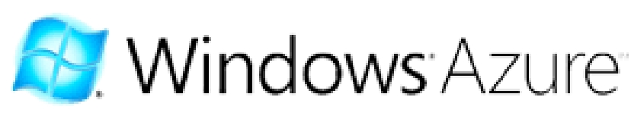

Azure is Microsoft’s equivalent of the GAE, and as you’d expect it is slightly more focused on the use of .NET components (it natively supports ASP.NET). It is also set up to support SQL Server databases (via the Azure Data Services system), which would significantly reduce the difficulty of migration for people used to Windows-based servers.
The Azure platform appears to be a modified form of Windows Server 2008; you get access to many of the usual technologies, including Internet Information Services (IIS), although this access would be via a web interface rather than Remote Desktop. Azure also supports non-Microsoft development languages including PHP and Python, which increases your options somewhat.
Azure uses an entirely pay-as-you-go pricing system, charging 12c per hour plus 15c per gigabyte of data stored (per month) plus 15c per gigabyte transferred. That leads to an estimated annual cost (for the equivalent of a mid-range server) of $1120, or around £700 (fluctuating with the exchange rate). This pricing does not include the separate licensing for SQL server, but unlike other suppliers Microsoft are able to offer this at very little extra cost. A gigabyte of database space costs $120 per year, though Microsoft do not make it clear whether this is for a logical database server, or just for a single database.
Microsoft intends in the near future to offer SharePoint via Azure, stretching it into the SaaS market. In the long run, they also intend to create a full Virtual Private Server (IaaS) version of Azure.
Using Azure would simplify the deployment process for ASP.NET developers, since Microsoft have apparently devoted a lot of time to ensuring that Azure deployment is possible “at the click of a button” directly from Visual Studio.

Security
The security objectives of an organization are a key factor for decisions about outsourcing information technology services and, in particular, for decisions about transitioning organizational data, applications, and other resources to a public cloud computing environment. The information technology governance practices of the organizations that pertain to the policies, procedures, and standards used for application development and service provisioning, as well as the design, implementation, testing, and monitoring of deployed or engaged services, should be extended to cloud computing environments.
To maximize effectiveness and minimize costs, security and privacy must be considered from the initial planning stage at the start of the systems development life cycle. Attempting to address security after implementation and deployment is not only much more difficult and expensive, but also more risky.

Need of security in Cloud Computing
These concerns involve computer and network intrusions or attacks that will be made possible or at least easier by moving to the cloud. Cloud providers respond to these concerns by arguing that their security measures and processes are more mature and tested than those of the average company. Another argument, made by the Jericho Forum, is: "It could be easier to lock down information if it's administered by a third party rather than in-house, if companies are worried about insider threats… In addition, it may be easier to enforce security via contracts with online services providers than via internal controls."
Concerns in this category include:
- VM-level attacks. Potential vulnerabilities in the hypervisor or VM technology used by cloud vendors are a potential problem in multi-tenant architectures. Vulnerabilities have appeared in VMWare, Xen, and Microsoft’s Virtual PC and Virtual Server. Vendors such as Third Brigade mitigate potential VM-level vulnerabilities through monitoring and firewalls.
- Cloud provider vulnerability. These could be platform-level, such as an SQL-injection or cross-site scripting vulnerability in salesforce.com. For instance, there have been a couple of recent Google Docs vulnerabilities. The Google response to one of them is here. There is nothing new in the nature of these vulnerabilities; only their setting is novel. In fact, IBM has repositioned its Rational AppScan tool, which scans for vulnerabilities in web services as a cloud security service (see Blue Cloud Initiative).
- Phishing cloud provider. Phishers and other social engineers have a new attack vector, as the Salesforce phishing incident shows.
- Expanded network attack surface. The cloud user must protect the infrastructure used to connect and interact with the cloud, a task complicated by the cloud being outside the firewall in many cases. For instance, shows an example of how the cloud might attack the machine connecting to it.
- Authentication and Authorization. The enterprise authentication and authorization framework does not naturally extend into the cloud. How does a company meld its existing framework to include cloud resources? Furthermore, how does an enterprise merge cloud security data (if even available) with its own security metrics and policies?
- Forensics in the cloud. This blog posting on the CLOIDIFIN project summarizes the difficulty of cloud forensic investigations: “Traditional digital forensic methodologies permit investigators to seize equipment and perform detailed analysis on the media and data recovered. The likelihood therefore, of the data being removed, overwritten, deleted or destroyed by the perpetrator in this case is low. More closely linked to a CC environment would be businesses that own and maintain their own multi-server type infrastructure, though this would be on a far smaller scale in comparison. However, the scale of the cloud and the rate at which data is overwritten is of concern.”

Current Security Scenario
1) Every breached security system was once thought secure:
SaaS (software as a service) and PaaS (platform as a service) providers all trumpet the robustness of their systems, often claiming that security in the cloud is tighter than in most enterprises. But the simple fact is that every security system that has ever been breached was once thought infallible.
Google was forced to make an embarrassing apology when its Gmail service collapsed in Europe, while Salesforce.com is still smarting from a phishing attack in 2007 which duped a staff member into revealing passwords.
While cloud service providers face similar security issues as other sorts of organizations, analysts warn that the cloud is becoming particularly attractive to cyber crooks. The richer the pot of data, the more cloud service providers need to do to protect it.
2) Data and information security:
In the realm of multi-tenant data, you need to trust the cloud provider that your information will not be exposed. For their part, companies need to be vigilant about how passwords are assigned, protected and changed as examples. Cloud service providers typically work with numbers of third parties, and customers are advised to gain information about those companies which could potentially access their data. However, realistically, this could be easier said than done.
An important measure of security often overlooked by companies is how much downtime a cloud service provider experiences. Ask to see service providers' reliability reports to determine whether these meet the requirements of the business. Exception monitoring systems is another important area which companies should ask their service providers about. An important consideration for cloud service customers, especially those responsible for highly sensitive data, is to find out about the hosting company used by the provider and if possible seek an independent audit of their security status.
Customers typically do not seem to be as stringent about data and information security as one might think they should in many cases.
3) Distributed cloud computing issues:
Let's say that you use a particular cloud provider for your eCommerce web presence. But your checkout and credit card transaction capabilities may be carried out using different servers in different data centers or even by different cloud providers. This may be happening with or without the customer's knowledge. This type of computing distribution is a very common cloud provider model. Cloud providers may have dozens of servers in dozens of data centers in dozens of Countries. If communications between the various cloud provider services is not strongly encrypted and extremely secure, your data and information could be at risk.
We maintained all of our own web and mail servers for many years (decades, actually). But the web page you are reading now is hosted on a cloud provider server. We were very careful to locate a provider that has strong ethics, is very competent and is likely to not go out of business tomorrow. We were particularly fortunate to find a provider that has it's offices and data center right here locally. But in our research, we found that this situation is the exception rather than the rule. Many cloud providers are located in Third World Countries and have questionable competency to say that least. One large provider that we looked at was so bad that their entire netblock was blacklisted by most SPAM e-mail black list authorities. We don't know (or care) whether this is because the cloud provider in question has a lot of open relay servers that have been hacked or whether they actively sell services to known spammers. And as for support... you'll come to value USA-based cloud providers and support teams the first time you have to contact them with issues or questions. Personally, we would think that trusting vital service applications to a company that was in Russia, China or India (as examples) would be a fundamentally bad idea. And just because the company headquarters are in the American heartland is no guarantee that the computers that are hosting your services aren't in Bangalore!
4) Security standards:
In most SaaS offerings, the applications are constantly being tweaked and revised, a fact which raises more security issues for customers. Companies need to know, for instance, whether a software change might actually alter its security settings. The cloud is still very much a new frontier with very little in the way of specific standards for security or data privacy. In many ways cloud computing is in a similar position to where the recording industry found itself when it was trying to combat peer-to-peer file sharing with copyright laws created in the age of analogue. In terms of legislation, there's very little that is specifically written for cloud computing. As is frequently the case with disruptive technologies, the law lags behind the technology development for cloud computing. What's more, many are concerned that cloud computing remains at such an embryonic stage that the imposition of strict standards could do more harm than good. IBM, Cisco, SAP, EMC and several other leading technology companies created an 'Open Cloud Manifesto' calling for more consistent security and monitoring of cloud services. But the fact that none of the main cloud providers agreed to take part suggests that broad industry consensus may be some way off.
There are handfuls of existing web standards which companies in the cloud should know about. Chief among these is ISO27001, which is designed to provide the foundations for third party audit, and implements OECD principles governing security of information and network systems.
The SAS70 auditing standard is also used by cloud service providers.
5) Local law and jurisdiction where data is held:
Possibly even more pressing an issue than standards in this new frontier is the emerging question of jurisdiction. Data that might be secure in one country may not be secure in another. In many cases though, users of cloud services don't know where their information is held. Currently in the process of trying to harmonize the data laws of its member states, the EU favors very strict protection of privacy, while in America laws such as the US Patriot Act invest government and other agencies with virtually limitless powers to access information including that belonging to companies.
Companies need to be confident that they have immediate access to all of their data should their cloud provider contract be terminated for any reason, so that their information can be quickly relocated. Part of this includes knowing in which jurisdiction the data is held.
European concerns about US privacy laws led to creation of the US Safe Harbor Privacy Principles, which are intended to provide European companies with a degree of insulation from US laws. Some suspect that "Counter terrorism legislation" is increasingly being used to gain access to data for other reasons.

Suggested Solutions
- Encryption
Homomorphic encryption alludes to an encryption where plain texts and cipher texts both are treated with an equivalent algebraic function. Now, the plain text and the cipher texts might also be not related but the emphasis is on the algebraic operation that works on both of them. This encryption method is all the rage at the moment, more so because homomorphic encryptions can be specifically designed and altered to suit particular purposes.
Secure Watermarking - Watermarking is a new age method of securing content and data. However, over the years too many faulty systems of watermarking had made it very easy for people to encrypt important data without the owners’ knowledge. With homomorphic encryption however, this problem is as good as gone. The encryption method concentrates on altering the ciphering to suit the individual data, effectively individualizing the watermark for the data.
The limitation of homomorphic encryption so far has been the incredible amounts of processing power required to handle all that secure crunching.
While encrypted cloud data would present some difficulties – such as indexing and searching – it would also offer a new degree of security from hackers. Without the decryption key, even if a server was raided and data stolen, it would be considerably more difficult to make malicious use of it. The expectation is that partial-homomorphic encryption is likely to show up in federal and medical record keeping initially.
Searching databases is usually done in the clear. And even if the query is encrypted, it has to be decrypted (revealing its contents) before it can be used by a search engine. What's worse is that databases themselves are stored as plaintext, available to anyone gaining access. The smarter way to handle sensitive information would be to encrypt the queries, encrypt the database and search it in its encrypted form. Impossible until now, "homomorphic" encryption scheme that allows encrypted data to be searched, sorted and processed without decrypting it.

- Compression
In computer science and information theory, data compression, source coding or bit-rate reduction is the process of encoding information using fewer bits than the original representation would use.
- Stegnography
Steganography is the art and science of writing hidden messages in such a way that no one, apart from the sender and intended recipient, suspects the existence of the message, a form of security through obscurity.
Generally, messages will appear to be something else: images, articles, shopping lists, or some other cover text and, classically, the hidden message may be in invisible ink between the visible lines of a private letter.
The advantage of steganography, over cryptography alone, is that messages do not attract attention to themselves. Plainly visible encrypted messages—no matter how unbreakable—will arouse suspicion, and may in themselves be incriminating in countries where encryption is illegal. Therefore, whereas cryptography protects the contents of a message, steganography can be said to protect both messages and communicating parties. Steganography includes the concealment of information within computer files. In digital steganography, electronic communications may include steganographic coding inside of a transport layer, such as a document file, image file, program or protocol. Media files are ideal for steganographic transmission because of their large size. As a simple example, a sender might start with an innocuous image file and adjust the color of every 100th pixel to correspond to a letter in the alphabet, a change so subtle that someone not specifically looking for it is unlikely to notice it.
- Tokenization
Tokenization is the process of breaking a stream of text up into words, phrases, symbols, or other meaningful elements called tokens. The list of tokens becomes input for further processing such as parsing or text mining. Tokenization is useful both in linguistics (where it is a form of text segmentation), and in computer science, where it forms part of lexical analysis.
System Design
Use Case Diagrams
- Consumer registration
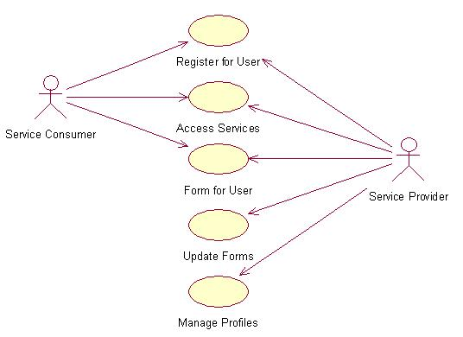
- Developer subscription
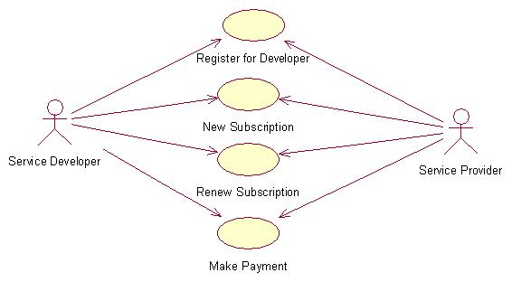

- Cloud Architecture
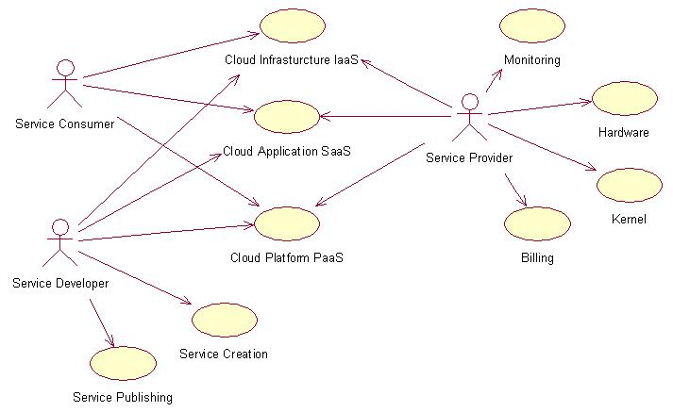

Technologies to be used
- CloudSim: simulation framework that enables modeling, simulation, and experimentation of emerging Cloud computing infrastructures.
- Eucalyptus: software platform for the implementation of private cloud computing on computer clusters.
- Windows: preferred OS.
- IBM WebSphere Application Server (WAS): application server.
- IBM HTTP Server: web server.

